A000-Afr-D R Congo-Songye-Mask-Scarifications—Sagittal crest-late 19th c

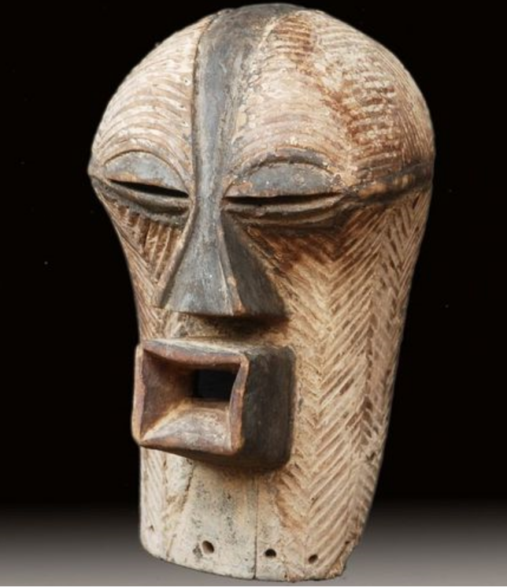

Afr-D R Congo-Songye-Mask-Scarifications—Sagittal crest-late 19th c

Case No.: 6

**Accession No.**

**Formal Label:** Afr-D R Congo-Songye-Mask-Scarifications—Sagittal crest-late 19th c

**Display Description:**

"Kifwebe masks were made for the Bwadi Bwa Kifwebe association, a type of policing society that   
provided a means of controlling social behavior and neutralizing disruptive elements within the   
group. These masks appeared at the installation and death of a chief, and at the initiation rites of   
young men as well as a whole range of occasions that included punishments, warfare and public   
works. There is great variety and symbolism within the various Kifwebe masks. More than thirty   
different mask names have been recorded. Several have animal names while other masks have   
names of illnesses like leprosy or names denoting natural phenomena. For the most part Kifwebe   
masks no longer function to maintain social control among the Songye except in the southeastern   
regions bordering on Luba territory.  
  
Female masks, in direct relation to the physical world and procreation, move calmly; their task is to   
invoke benevolent spirits that will influence the future generation. Female masks are associated   
with the moon and are worn for moon rituals as well as during funerals and initiation rites."  
Beauty and the Beasts: Kifwebe and Animal Masks of the Songye, Luba and  
Related Peoples by Marc Leo Felix

**Accession Number:**

**LC Classification:**

**Date or Time Horizon: late 19th c**

**Geographical Area:**

**Map:**

**GPS coordinates:**

**Cultural Affiliation:**

**Media: wood, kaolin wash**

**Dimensions:** 11.4 in ( 29 cm )

**Weight:**

**Condition:** Slight crack - old African repair - right side

**Provenance:** Songye. Congo, Songye tribe

**Discussion:**

**References:**

Felix, Marc Leo. Beauty and the Beasts: Kifwebe and Animal Masks of the Songye, Luba and  
Related Peoples.

|  |
| --- |
|  |

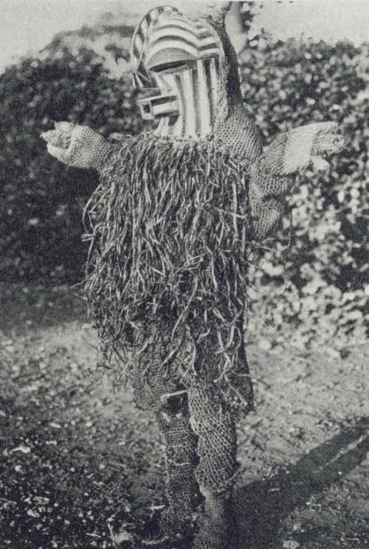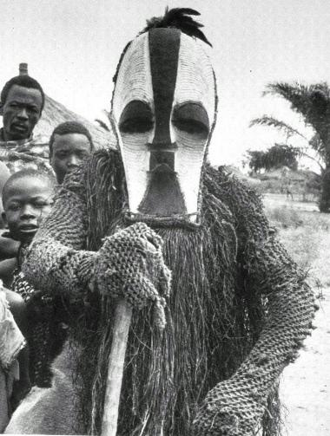

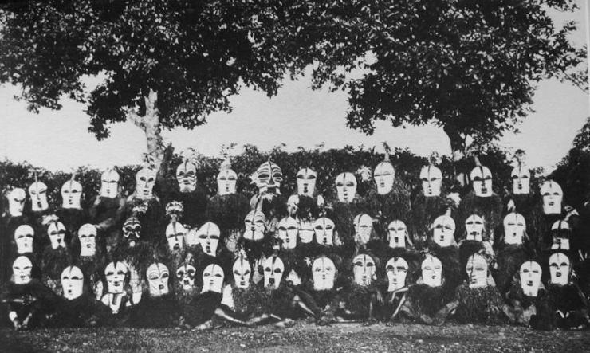

|  |
| --- |
| Group of Songye bifwebe masks photographed in the Congo in 1934 - Illustration Congolaise |

**KIFWEBE MASKS**According to the specialists, Anthropologists and Art Historians, Kifwebe masks (sing.) or Bifwebe (plur.) are   
differentiated; by gender and by their shape and size but also by the basic surface coloration and the decorative   
design and patterns on the surface. The masks said to represent a female are rarer than masks supposed to   
depict a male. In the field I have never seen more than one female mask at a time, yet groups of male masks are   
commonly encountered. Normally a band of mask-wearers is made up of one female mask and a number of male   
masks. All of the wearers, of course, are male. Most Songye female masks have a grooved surface that is   
painted over with white kaolin (pembe or ntoshi), and when the mask is worn repeatedly, this white partially   
wears off, exposing the natural wood. This exposure heightens the white/brown contrast and reveals the   
engraved striations. But when a mask is stored in a smoky environment the white surface darkens considerably.   
A black (tar, or composite resinous material) vertical stripe running from the top of the head, over the nose, and   
widening at the chin, divides the face in two. The eyes are lidded in black, and dark-red resin or red natural   
pigment (nkula) (sometimes European paint nowadays) will usually highlight the mouth and sometimes the eyes.   
When the surface paint has worn of or is soiled the masks are repainted.  
  
Female masks will have no sagittal crest or perhaps a slightly raised flat one. Female masks exude beauty,   
tranquility and inner peace. They are not aggressive, either in their appearance or in their behavior.  
  
Male masks, on the other hand, are aggressive in their general appearance as well as in their comportment   
during their performances and village visits.  
  
There are at least two kinds of masks said to represent males, it is believed they represent the senior and the   
junior. The senior is usually larger in size, with a big sagittal crest which can be a separate formal entity, or a   
continuation of the forehead protruding above the forehead. The crest and the conical protrusion are supposed   
to contain the magical strength of the mask, hence the bigger the crest the more powerful the mask.  
  
It is said that male masks (or their wearers) are involved in witchcraft, sorcery, spell-casting and dispersion of   
diseases and epidemics. The junior mask is smaller in size and will have a smaller crest but has the same   
contrasting coloration as the senior mask, mainly black, white, and dark red. Obviously symbols are attached to   
this use of colors, but since informants (and scholars) don't agree on the symbolic meaning of each of these   
basic colors. I will refrain from citing them or expressing a personal opinion.  
  
Kifwebe are made out of wood and come in many shapes and sizes, depending on the area where they were   
made or their function. Basically, the masks made to be worn come in male, female, or youngster versions, the   
females usually are white and have no crest, the males are polychrome and will have a crest. When masks are   
worn they are part of a complete costume consisting of a hood attached to the mask, a shirt and pants made   
from woven bark. The soles of his shoes will be elephant skin and a striped fur belt completes the costume. The   
top of the mask will have attached to the hood a plummet and a fibre beard will circle the masks face. The   
mask-wearer will carry in his hands items allowing to further identify the portrayed character such as a staff,   
knife, stick or twigs. Other masks are made to be hung in meeting houses; these are sometimes affixed to a   
plaque. The main function of worn masks is to control social order. Other masks serve to protect and identify a   
person or place with the Kifwebe association. Another type of masks, made in a variety of materials such as   
leaves, feathers, woven fibers or bark, are used in an initiatic context. The icon of the masking association   
(kifwebe) will also appear in miniatures worn as charms, as well as on knives or shields.  
  
**THE MANY MEANINGS OF KIFWEBE MASKS**When one asks Songye men what a Kifwebe mask represents, the answers will vary greatly, but the gist will be   
that the mask basically depicts supernatural beings, such as ancestor spirits (katotoshi) visiting their   
descendants: a beautiful fertile woman on one hand and a strong virile man on the other hand. Many, however,   
will describe a spirit/creature incorporating a variety of animals, or a composite being consisting of mixed human   
and animal elements. According to the literature, all the masks we have discussed, are said to represent either a   
male, when they have a big sagittal crest; or a female, when they have no crest or a very small flattened one ).   
Masks that are smaller in size (but not miniatures) or have a small sagittal crest are said to represent a junior. (*I   
have seen masks described as being the "youngster" only among the eastern Songye; in the center there was   
only the male/female differentiation to be noticed, whereas in the west even genderization becomes hazardous*)  
  
Female masks are predominantly white with a few touches of black (eyelids, nose, sagital line, chin) and red   
mouth, eyes), whereas in male masks the dominant color is red, with black and white highlights. According to   
some of my initiated Songye friends, white is perceived as a peaceful color associated with purity and the spirits,   
red is considered a more active color often associated with blood and vital power, and black is linked with   
secrecy and witchcraft.  
  
Even though some scholars maintain that kifwebe masks were only in¬vented at the beginning of the 20th   
century, this assertion is most probably wrong since these masks had already been noticed and collected in the   
last quarter of the 19th century by early travellers. Furthermore, it is impossible to believe that such a powerful   
"gestalt" as the kifwebe mask could have developed so fast and become so wide spread in such a short time   
span. On the contrary, I am convinced that kifwebe in its various forms and guises is a very old idea, and that   
even though there have been changes and transformations to its shape in the last 100 years, one finds   
throughout the basic idea of a striated, exophtalmic, anthropo-zoomorphic face with a jutting mouth. Today,   
masks are still found dancing in Songyeland, especially in the eastern part. They can be used in altered forms   
or context (secular) and therefore no longer inspire the fear and awe they once did. Obviously, in the past,   
masks played a crucial role in Songye society as they bound men together in strong and powerful brotherhoods   
or associations, the role of which was to initiate, to control social order and to serve as a counterforce to the   
chieftains and noble castes.  
  
Animals are also represented, albeit in a symbolic way, in the "classical" Kifwebe masks, according to many   
informants. Stripes are associated with a variety of capridae (antelope etc.), zebra and okapi. Other animal   
representations cited include the crocodile (chin), chameleon (eyes), monkey (eyes), ape (sagittal crest),   
rooster (crest), owl (feathered horn), buffalo (some large curved stripes on cheeks), anteater or aardvark   
(mouth), pangolin (tiered surface). The small crest of the "youth" mask, I was told, depicts the sagittal crest   
found on the skull of male apes, whereas the big crest represents the one found on the head of roosters and   
other crested birds. But some informants told me that the concentric circles and striations on the face of the   
mask in fact refer to the actual faces of people who in the past had their faces scarified with concentric circles;   
why not?  
  
Some authors have tried to decode Kifwebe masks much further, assigning one or more symbolic meanings to   
each of its parts. Since I have not confirmed this information in the field, I will not repeat it or offer my own   
speculation, since symbolism is not my forte. It is possible that over the years the esoteric meaning and iconic   
content of Kifwebe masks have become more complex or changed so as to adapt to new ideas (due to colonial   
interference a lot of esoteric knowledge was lost). At first the masks probably depicted only forest animals or   
their spirits. But when the Songye left their forest habitat and lifestyle to live in the savanna, they settled down   
and created semipermanent villages, with specific burial places. At this point an ancestor cult was probably   
introduced. In order to honor important forebears and invoke their help in solving the problems of the living, the   
imagery of male and female human spirits was then incorporated into the mask's iconography. Or else the idea   
of representing humans in their masks was borrowed from neighbors who used the human icon in their typology.  
  
**FUNCTION OF KIFWEBE MASKS**Among the Songye, Kifwebe masks are used for a variety of occasions. I have seen groups of mask-wearers   
going from compound to compound to collect donations for their association, and once I witnessed a group of   
masks performing at dusk to honor a deceased member of the Kifwebe association. I also had a furtive glimpse,   
before being chased away, of a female mask and a few male masks gathered in a house of an abandoned   
compound. On another occasion a masked dance was staged to welcome me (and my gifts) to the village.   
Except for these instances I have no firsthand observations of the masks in use, but I have seen, and collected,   
many masks at rest in the field. I asked many questions, but these were answered with reluctance and not very   
precisely. The answers varied greatly depending on whether I asked "average" villagers or men I suspected to   
be members of the Kifwebe association. Yet we can conclude that masks are used in many circumstances, and I   
will list here the various contexts in which the Songye could use their Kifwebe masks. (These same   
circumstances apply to similar masks in neighboring areas of the southern savanna, including the Luba   
Batembo, Luba Hemba, Luba Shanka-di or Luba Katanga and Luba Upemba, Zela, Kunda, Kaonde, Kanyok,   
Kalundwe, Bwile, Tabwa, Lunda.) We shall meet these neighbors' interpretations of their masks in a later section.  
  
- During initiation procedures worn by the leader of the initiation, by initiators, (by initiates, by initiated?), by   
circumcisers, by the guardians of the circumcision camp.  
- To celebrate seasonal events such as new moon, seeding of crops, first harvesting, first rain.  
- To enforce social control policing, levying of taxes and fines, rendering of justice, execution.  
- To educate and instruct mask-wearers in stage plays depicting the social do's and don'ts.  
- To act as a mnemonic and moralistic device when maskers re-enact mythical or historical events from the past,   
or stage moralistic folktales based on animal and human characters.  
- To honor the deceased at funerary ceremonies, maskers accompany and honor important members of society   
either at funerals or funeral commemorations.  
- To sanctify nominations of titleholders, ritual specialist and enthronement of chiefs.  
- To supervise communal duties such as ditch-cleaning, fortification, road and bridge building.  
- During gathering of associations worn during meeting of members of brotherhoods, associations and societies.  
- To solve crisis or conflict worn by a medium between the living and higher powers or spirits, to gain assistance   
in solving temporary crises such as war, strife, enmity, calamities and epidemics.  
- During hunting worn before or after the hunt, to conduct or super¬vise a communal hunt.  
- During warfare to encourage and bless warriors, worn to bring good luck to a war campaign or lead warriors,   
used in emblem form carved on shields.  
- Purification to cleanse polluted people or areas.  
- Healing to assist in the mental or physical healing process.  
- Entertainment to entertain the community on the occasion of a public festival or festive occasion.  
- Honoring to honor visitors or specific members of the community.  
- Witchcraft some maskers are said to be sorcerers and masks to contain magical powers.  
- To dispense fertility and wealth Female masks are said to enhance fertility of humans, animals, and the earth;   
male masks would bring power and wealth.  
  
Source: "Beauty and the Beasts - Kifwebe and animal masks of the Songye, Luba and related peoples."  
MARC LEO FELIX

